**Project Design Phase-II**

**Technology Stack (Architecture & Stack)**

|  |  |
| --- | --- |
| Date | 12 May 2023 |
| Team ID | NM2023TMID01052 |
| Project Name | Project –  “AI Enabled Car Parking Using OpenCV” |
| Maximum Marks | 4 Marks |

**Technical Architecture:**

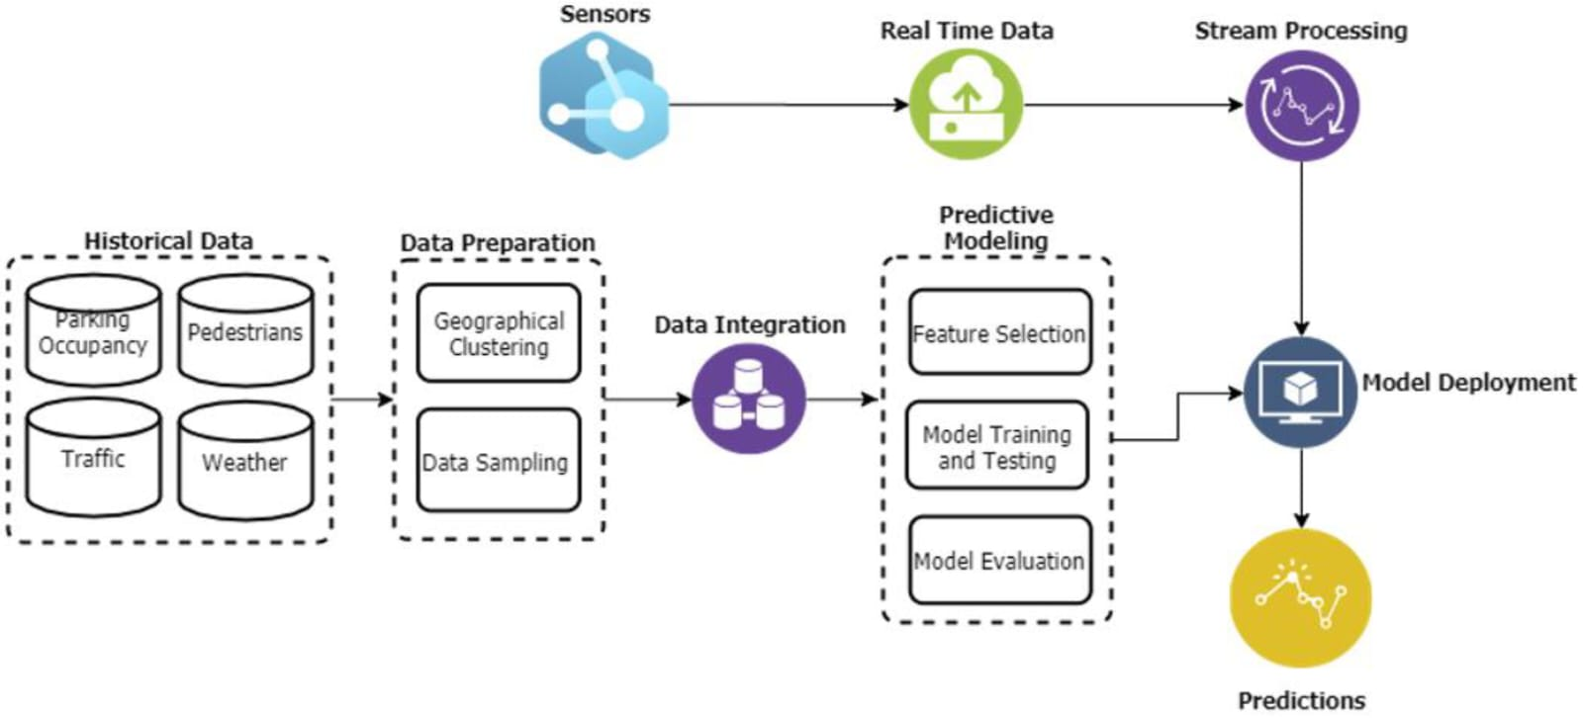

**Table-1: Components & Technologies:**

|  |  |  |
| --- | --- | --- |
| **S.No Component** | **Description** | **Technology** |
| **Application Logic-1** | Logic for a process in the application | Python |
| **Application Logic-2** | Logic for a process in the application | Python Flask |
| **Cloud Database** | Database Service on Cloud | IBM DB2, IBM  Cloudant etc. |
| **File Storage** | File storage requirements | Local Filesystem |
| **Machine Learning Model** | Purpose of Machine Learning Model | Predictive Modelling |
| **Infrastructure**  **(Server / Cloud)** | Application Deployment on Local System / Cloud  Local Server  Configuration: Built on  Flask Web Server | Local Server |

**Table-2: Application Characteristics:**

|  |  |  |
| --- | --- | --- |
| **S.No Characteristics** | **Description** | **Technology** |
| **Open-Source Frameworks** | List the open-source frameworks used | OpenCV  Framework using  Python |
| **Security**  **Implementations** | List all the security / access controls implemented, use of firewalls etc. | Flask Security |
| **Scalable Architecture** | Justify the scalability of architecture | Three-Tier Architecture |
| **Availability** | Justify the availability of application |  |
| **Performance** | Design consideration for the performance of the application (number of requests per sec etc.) | High Performance |